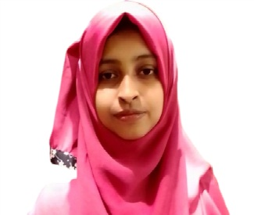

**Objective**

Dedicated and motivated Computer Science student seeking a Teaching Assistant or Research Assistant position to leverage my technical skills and passion for teaching to support faculty and enhance the learning experience for students.

**Education**

**Higher Secondary School Certificate**   
Puran Bazar Degree Collage, Chandpur  
GPA: 5.00, December, 2021

**Bachelor of Science in Computer Science Engineering**  
Presidency University, Gulsan, Dhaka  
GPA: 3.8.5 out of 4 (last sem), Expected Graduation: December, 2026

**Skills**

* **Programming Languages:** C, Python, Java
* Confident at Math & Problem Solving
* **Soft Skills:** Strong communication, teamwork
* **Language Skill:** Bangla and English
* MS Office (Word, Excel, Power point)
* **Others:** Leadership, Team work, Good Communication

**Experience**

**Assistant Trainer**  
 Computer Gallery Institute, Chandpur  
 May, 2021 – July, 2022

**Co-curricular activities**

* Participating and working for Undergrad Math Olympiad
* Tresurer of Programming Club

**Certifications**

* Computer Office Application, BTEB, Dhaka, June-2019]
* Participation of NUMO, Department of Science and Humanities, MIST,2023